Money Matters
Financial Outlook for the County Council
Medium Term Financial Strategy & Reserves as at 30th June 2019

 | Contents | Page
1 | Executive Summary | 3
2 | Funding | 7
3 | Net Budget Requirement | 11
4 | Reserves | 16
5 | Future Risks and Opportunities | 18

- Executive Summary

At full council in February 2019 the medium term financial strategy (MTFS) set out a forecast funding gap of £47.326m by the end of the 4 year period (2019/20 – 2022/23).

This report provides an updated position covering the 2020/21 – 2022/23 financial years. This MTFS covers a 3 year period rather than the previously reported 4 year period due to the ongoing and unprecedented uncertainty in relation to future local government funding and to enable a direct comparison with the previously reported position. There are a significant number of variables leading to a range of different funding scenarios being explored, but without any clarity having been provided at this point in time it is difficult to settle on a central or realistic scenario. A review of assumptions, relating to both income and expenditure, has been undertaken to reflect the most current information available.

The updated funding gap contained within the report has increased to £64.755m by 2022/23 which is an increase of £17.429m from the previously reported position, however a reduced budget gap is forecast for 2020/21 of £5.895m. The main reasons for the changes to the position are as follows:

- Increased funding expectations in 2020/21. The previous MTFS position had assumed revenue support grant (RSG) would end in 2019/20, however the likelihood of a one year settlement and roll forward budget in 2020/21 has led to an assumption that RSG will be included within the baseline funding level for 2020/21. This position has been recommended by CIPFA and other professional advisers but has not been categorically confirmed by the government.
- Staff salary inflation has been changed from the previous 1% to 2% annual increases. This has increased the financial gap by c£3.5m per annum and £11.378m over the 3 year period, and is therefore the most significant contributory factor to the increased forecast gap.
- Service demand and volume changes and inflation and cost changes have increased costs by a net sum of £1.256m. This is primarily the outcome of increases in the levels of demand across services such as children's social care and transport, offset by some service cost adjustments due to changes to service configuration, particularly in relation to support service delivery models.
- Service cost adjustments of £3.483m reflecting undeliverable savings pressures.

Although the forecast funding gap in 2020/21 has reduced, the position still reflects a shortfall with a revised gap over the next 3 years of £64.755m, which varies over each of the 3 years shown in Table 1. Work is progressing on phase two of the service challenge process which will seek to address the ongoing deficit and is focusing on a number of cross-cutting work streams and areas for investigation and review identified in the initial phase, but where further work is needed to robustly evidence the scale and form of proposals. In particular, service challenge phase 2 is focused on the complex levers required to create an environment where service configuration and operational practice reflects best in class and supports demand management which is the single biggest driver on our costs. A separate report on this issue is included in this cabinet's agenda and further saving proposals will come forward for consideration at future cabinet meetings.

The revised funding gap also makes assumptions about future funding levels and there remains significant uncertainty about this post 2019/20 with changes to be made in respect of business rates retention, the overall funding formula, the anticipated green paper on adult social care and, of course, any government spending review.

The value of the uncommitted transitional reserve is currently forecast to be sufficient to meet the identified funding gaps through to 2022/23, which provides time to address the structural deficit in a considered and sustainable way. The intention remains to identify continued savings and reduce the call on the transitional reserve, for 2020/21 and beyond.

The table on page 4 provides a detailed analysis of movements between the previously reported financial gap and the revised financial gap:

Table 1

 | 2020/21 | 2021/22 | 2022/23 | Total
 | £m | £m | £m | £m
Spending Gap as reported to Full Council | 30.370 | 5.518 | 11.438 | 47.326
Add change to forecast of spending:
Pay & Pensions | 4.460 | 3.448 | 3.470 | 11.378
Inflation and Cost Changes | 0.373 | -3.118 | -0.352 | -3.097
Service Demand and Volume Pressures | 2.805 | 1.172 | 0.376 | 4.353
Other | 0.025 | 0.000 | 0.000 | 0.025
Undeliverable Savings | 3.483 | 0.000 | 0.000 | 3.483
Total Change to Forecast of Spending | 11.145 | 1.502 | 3.494 | 16.141
Change to forecast of resources:
Funding | -35.621 | 32.014 | 4.895 | 1.288
Total Change to Forecast of Resources | -35.621 | 32.014 | 4.895 | 1.288
Funding Gap | 5.895 | 39.034 | 19.826 | 64.755
Forecast net budget requirement | 822.956 | 841.591 | 842.891
Funding | 817.061 | 802.558 | 823.065

Aggregated Funding Gap | 2020/21 | 2021/22 | 2022/23
2020/21 (£m) | 5.895 | 5.895 | 5.895
2021/22 (£m) |  | 39.034 | 39.034
2022/23 (£m) |  |  | 19.826
2023/24 (£m)
Total | 5.895 | 44.928 | 64.755
Previous position (£m) | 30.370 | 35.888 | 47.326
Variance (£m) | -24.475 | 9.040 | 17.429

The graph below demonstrates the drivers that make up the changes in the financial gap from £10m carried forward from 2019/20 to the cumulative position of £65m in the financial year 2022/23 as shown in the table above:

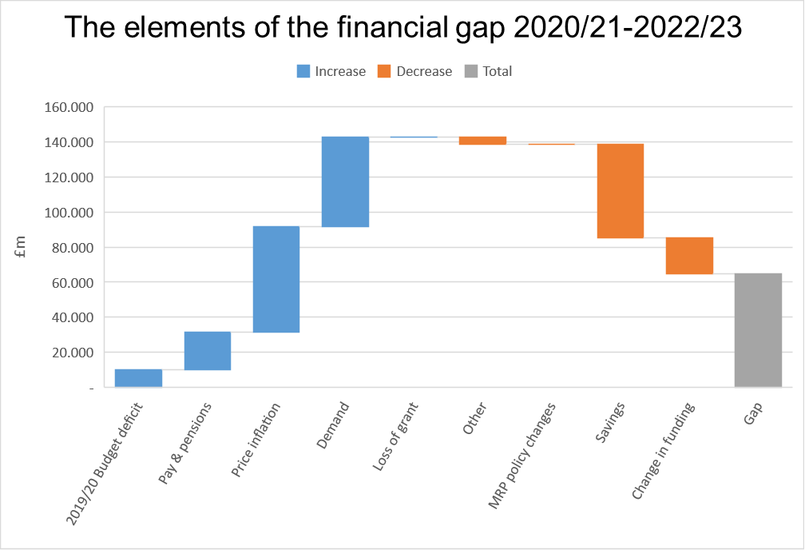

2. Funding

The funding included within this report reflects the final settlement for 2019/20 that was announced on 29th January 2019. As there are new models of funding proposed from 2020/21 due to the implementation of business rates retention and a new funding formula there are no funding levels confirmed post 2019/20. Assumptions have therefore been made for funding levels from 2020/21 – 2022/23 that are detailed within this report.

Spending Review, Fair Funding Formula and 75% business rates retention

At the time of writing this report the implementation date for a new system of local government finance, the "fair funding formula", is officially still scheduled for 2020/21 and involves local government retaining 75% of the business rates along with the new funding formula coming into effect. However, details of the scheme and therefore the impact on Lancashire are not yet known, with further consultations due to be circulated imminently for the various funding blocks. One of the key and consistent responses from councils in previous consultations has been for early indication of the impact of funding changes to be provided, to enable sufficient time for planning to take place to help effectively manage those changes. At this stage it now seems highly unlikely that the new schemes will be implemented for the 2020/21 financial year, due to the amount of consultation and modelling required, combined with pressures across government departments in relation to the UK exiting the EU.

The most recent communication in relation to future funding was from the Chancellor in early August who announced that a one year spending review will be completed in mid-September. The Secretary of State indicated that this will give councils certainty about how local services will be funded in 2020/21 as they begin the budget setting process. The position is that during 2020 a multi-year spending review will take place which will allow more time for the impact of funding changes to be effectively planned for.

The table below reflects the updated funding position.

Table 2

 | 2020/21  £m | 2021/22  £m | 2022/23  £m
Revenue Support Grant* | 0.000 | 0.000 | 0.000
Business Rates | 235.902 | 206.787 | 209.979
Council Tax | 512.289 | 531.366 | 551.153
New Homes Bonus | 3.161 | 3.196 | 3.224
Better Care Fund | 45.532 | 45.532 | 45.532
Capital receipts | 7.000 | 2.500 | 0.000
Social Care Grant | 9.427 | 9.427 | 9.427
Collection Fund Surplus | 3.750 | 3.750 | 3.750
Total | 817.061 | 802.558 | 823.065
Funding – Previous MTFS | 781.440 | 798.951 | 824.353
Variance | 35.621 | 3.607 | -1.288
Impact on financial gap | -35.621 | 32.014 | 4.895

* As part of the business rates pilot and subsequent retention scheme local authorities forgo their right to the revenue support grant (RSG) and this is encompassed within the business rates baseline. The value of RSG has been included in 2020/21 baseline figures, but not from 2021/22 onwards.

2.1 Council Tax and Business Rates

Council Tax

The MTFS currently reflects the following assumptions in relation to the county council's council tax increases as previously reported to cabinet, however this is a decision for full council to make each year when setting the budget.

Table 3

 | Council Tax increase (no referendum required) | Additional council tax flexibility | Adult Social Care Precept | Total council tax increase
2020/21 | 1.99% | 0.00% | 0.00% | 1.99%
2021/22 | 1.99% | 0.00% | 0.00% | 1.99%
2022/23 | 1.99% | 0.00% | 0.00% | 1.99%

From 2020/21 onwards, it is assumed the maximum increase that the county council is able to apply to council tax, without a referendum, is 1.99%. This continues the assumption that the options to raise an adult social care precept and the additional 1% flexibility cease after 2019/20. Any decisions not to increase council tax in line with the assumptions above would increase the financial gap; every 1% in council tax yields c£5m.

Within the current MTFS a tax base increase of 1.7% is included, which is the same position as in the previously reported MTFS based on historical average increases. However, in the most recent data available the tax base forecast position for 2019/20 for Lancashire was 1.4%. At this stage the average increase of 1.7% has been maintained within the MTFS, as we anticipate having an offsetting increase on the collection fund (which has also not been built into the MTFS at this stage) that could be increased due to prudent estimations of growth from district councils, based again on historical surplus positons.

Business Rates

Business rates income is a significant portion of funding to local authorities. The baseline is an assessment of the business rate income required to meet service needs. For the county council, the amount anticipated to be received from the business rates collected in the area is less than its assessed need and therefore we receive a top up grant. We also build in a small amount of growth into the MTFS for our local share at 0.5%.

As part of the final settlement the Secretary of State announced that the Lancashire bid to become a pilot of 75% business rates retention had been successful. At this stage in the financial year we have no further information in relation to the continuation of 75% pilots in 2020/21. As we would have expected further information to be released at this stage in the financial year if additional applications could be put forward we have assumed that the pilot continues into 2020/21 and beyond.

The key assumption in relation to business rates and the continuation of the pilot centres around the baseline level of funding and the inclusion of the revenue support grant (RSG). When a council agrees to be a pilot it foregoes its RSG as this is added in to the baseline position of the business rates pilot. In previous assumptions in the MTFS we had assumed that RSG would be removed in line with indications from MHCLG. However, given the lack of information available at this stage in the financial year we have sought professional advice from experts in local government finance and they have advised that they would assume that the RSG rolls forward in 2020/21 only to maintain the baseline level of funding. This is a significant amount, with the impact being c£35m, therefore if this advice is incorrect this will worsen the financial gap in 2020/21. For future years we have maintained our working assumption that RSG will cease.

2.2 Capital Receipts

In April 2016 the government introduced the flexibility for capital receipts to be used to fund revenue expenditure that is designed to generate ongoing revenue savings or service improvements. This flexibility is currently available until 2021/22.

Capital receipts of £7m and £2.5m are estimated to be received over the next two years and are included within the MTFS. As part of the service challenge process additional resources were identified to support the transformation of services and delivery of the savings. The assumption within the MTFS is that there will be sufficient capital receipts to meet these transformation costs over the next 2 years and therefore they will not be a draw on reserves or increase the funding gap.

3. Net Budget Requirement

The MTFS covers spending pressures including pay increases, contractual inflation, increased demand for services and the impact of previously agreed and new savings measures.

3.1 Pay and Pensions

In the previous MTFS an assumption of a 1% annual pay award was included from 2020/21 onwards until further information was known. However, at this stage in the financial year and with information that negotiations are commencing at higher rates than 2% it has been determined prudent to increase to 2% to reflect previous year agreements. This will be reviewed quarterly and may require additional funding if a higher percentage increase is agreed. A 1% pay award equates to an additional net annual cost of c£3.5m. The pension prepayment saving adjustment represents a reversal of the discount on employer pension contributions made upfront in 2017/18, at the point of the last revaluation, and covering contributions due up to and including 2019/20.

The table below presents the amounts built into the MTFS for pay and pensions:

Table 4

 | 2020/21  £m | 2021/22  £m | 2022/23  £m | Total  £m
Employee Costs | 8.952 | 7.491 | 7.570 | 24.013
Pensions Costs | -6.026 | 0.374 | 0.374 | -5.278
Pension Prepayment Saving | 2.299 | 0.000 | 0.000 | 2.299
Other pay related costs | 0.029 | 0.028 | 0.028 | 0.085
Revised Pay and Pension requirements | 5.254 | 7.893 | 7.972 | 21.119
Pay and Pensions -previous MTFS | 0.794 | 4.445 | 4.502 | 9.741
Impact on Financial Gap | 4.460 | 3.448 | 3.470 | 11.378

3.2 Price Inflation and Cost Changes

Contractual price increases represent a significant cost pressure to the county council. The assumptions have been subject to regular review by services, with a decrease of £3.097m identified when comparing the values within the previous MTFS. This is primarily resulting from service cost adjustments due to changes to service configuration, particularly in relation to support service delivery models.

Table 5

 | 2020/21  £m | 2021/22  £m | 2022/23  £m | Total  £m
Adults Services | 16.360 | 12.380 | 13.147 | 41.887
Children's Services | 1.827 | 1.536 | 1.441 | 4.804
Waste Services | 1.870 | 2.347 | 2.578 | 6.795
Transport Services | 1.397 | 1.463 | 1.553 | 4.413
Other Services | 2.213 | -1.492 | 1.800 | 2.521
Revised price inflation requirements | 23.667 | 16.234 | 20.519 | 60.420
Price inflation – previous MTFS | 23.293 | 19.352 | 20.871 | 63.516
Impact on Financial Gap | 0.373 | -3.118 | -0.352 | -3.097

3.3 Demand Pressures

All services have reviewed the demand pressures they face in future years and increasing demand still remains a significant element of the funding gap. The MTFS at quarter 1 forecasts increased requirement of £4.354m when comparing to the previous MTFS.

Table 6

 | 2020/21  £m | 2021/22  £m | 2022/23  £m | Total  £m
Adults Services | 16.585 | 9.473 | 10.163 | 36.221
Children's Services | 5.454 | 2.029 | 1.588 | 9.071
Waste Services | 0.471 | 0.983 | 1.048 | 2.502
Transport Services | 0.982 | 0.907 | 0.606 | 2.495
Other Services | -0.424 | 0.945 | 0.052 | 0.573
Revised Demand Requirements | 23.068 | 14.337 | 13.457 | 50.862
Demand – previous MTFS | 20.263 | 13.165 | 13.080 | 46.508
Impact on Financial Gap | 2.805 | 1.172 | 0.377 | 4.354

Adult social care represents a large proportion of the demand pressures. Adult Social Care has long seen annual increases in the demand for services and the MTFS attempts to predict growth in future years largely based on reviewing current and past activity trends and also taking into account future population changes, particularly with regard to the ageing population. From a social care perspective demand covers both increasing numbers of people eligible for support and the increasing complexity of those cases. The level of demand included for this service area has remained at the same value as the previous MTFS but will continue to be monitored and figures may be updated in future MTFS reports.

Children's social care continues to experience demand pressures across the service, particularly in relation to placement demand due to the number of looked after children in Lancashire. The funding requirement for children's social care has increased by c£2.3m over the 3 year period to reflect increased demand across children looked after placements and family support for children with disabilities. We are looking at best practice sites across the country to explore opportunities to reduce demand in a way that delivers better outcomes for children but as yet no formal conclusions have been reached and hence it is not included in the MTFS.

The budget for waste services continues to see a reduced level of growth. The reduction is due to lower than projected waste arising increases influenced by the agreed investment in waste minimisation. This has resulted in a reduction of £0.465m in the level of demand required in 2020/21.

The public and integrated transport budget continues to see rising demand pressures. As part of this MTFS an additional c£2.4m has been budgeted for across 2020/21 – 2022/23.

3.4 Undeliverable Savings

There is a rigorous monitoring process of agreed savings in place and several savings have been classified as undeliverable due to changing circumstances and consultation feedback, and it has not been possible for services to identify alternative offsetting savings in the timeframes involved. The following savings are built back into the budget at quarter 1:

- SC507 – Change of sleep in rates - £2.1m
- Residential Strategy – Increased utilisation of in-house residential provision - £0.996m
- SC102 – Transfer of cases to children awaiting adoption team - £0.197m

In addition, a further saving was agreed in January 2018 relating to the redirection of the work of the Supporting Carers of Children and Young People Looked After Together service in order to generate additional income from the adoption support fund (£0.450m). This saving has also been classified as undeliverable but the service has been able to identify recurring underspends in other areas that has offset this pressure and doesn't therefore need to be added back into the budget. This has also negated the requirement for consultation of the original savings proposal.

3.5 Additional Savings

The initial service challenge process necessarily focused on individual service reviews supported by benchmarking data which identified a number of areas where the council was high cost compared to a number of other county councils. The aim was to deliver the same or better outcomes at reduced cost wherever possible and phase 1 of the service challenge process identified £77m of savings proposals which were included both within the 2019/20 budget and the MTFS position. Updated financial benchmarking data covering the 2019/20 budget supports an overall positive change in the cost of service position of the council relative to other county councils, but with some services still remaining at a relatively significant higher cost overall than the mean or median county council. This is largely driven by higher demand and operational practice.

Phase 1 also identified a number of cross-cutting work streams and areas for investigation and review which is being taken forward as part of the service challenge phase 2 process. These work streams are necessarily complex, requiring a fundamental challenge of, in many cases, longstanding organisational approaches, systems and processes to enable both service improvements and cost savings to be identified. Work is progressing on phase 2 with demand management and organisational development key areas of focus with a separate report on this cabinet meeting agenda and further saving proposals to come forward for consideration at future cabinet meetings.

4. Reserves

Table 7
Reserve Name | Opening balance 2019/20 | 2019/20 Forecast Expenditure | Forecast Contribution to/from Reserves (Other Revenue e.g. Schools) | 2019/20 forecast transfers to/from other reserves | Forecast Closing balance 2019/20 | 2020-21 Forecast Spend | 2021-22 Forecast Spend | Forecast closing balance 31 March 2022
 | £m | £m | £m |  | £m | £m | £m | £m
County Fund | -23.437 | 0.000 | 0.000 | 0.000 | -23.437 | 0.000 | 0.000 | -23.437
SUB TOTAL - COUNTY FUND | -23.437 | 0.000 | 0.000 | 0.000 | -23.437 | 0.000 | 0.000 | -23.437
Strategic Investment Reserve | -2.096 | -0.646 | 0.000 | 0.000 | -2.742 | 1.596 | 0.146 | -1.000
Downsizing Reserve | -7.445 | 4.605 | 0.000 | 0.000 | -2.840 | 2.840 | 0.000 | 0.000
Risk Management Reserve | -2.804 | 1.203 | 0.000 | 0.000 | -1.601 | 0.800 | 0.800 | 0.000
Transitional Reserve | -164.254 | 14.003 | 0.000 | 0.000 | -150.250 | 2.452 | 0.304 | -147.495
Service Reserves | -13.251 | 10.408 | 0.000 | 0.000 | -2.843 | 0.725 | 0.547 | -1.571
Treasury Management Reserve | -10.000 | 0.000 | 0.000 | 0.000 | -10.000 | 0.000 | 0.000 | -10.000
SUB TOTAL - LCC RESERVES | -199.850 | 29.574 | 0.000 | 0.000 | -170.276 | 8.413 | 1.797 | -160.066
Schools/Non-LCC Service Reserves | -17.528 | 2.808 | 0.000 | 0.000 | -14.720 | -0.174 | 1.419 | -13.475
SUB TOTAL SCHOOLS/NON LCC RESERVES | -17.528 | 2.808 | 0.000 | 0.000 | -14.720 | -0.174 | 1.419 | -13.475
GRAND TOTAL | -240.814 | 32.381 | 0.000 | 0.000 | -208.433 | 8.239 | 3.216 | -196.978

The county fund shown at the top of Table 7 is the balance set aside to cover the authority against a serious emergency situation (e.g. widespread flooding); a critical and unexpected loss of income to the authority and for general cash flow purposes. In considering these various factors the county council is forecast to maintain its County Fund balance at £23.437m, equating to c3% of net budget.

The value of the uncommitted transitional reserve is currently forecast to be £150.250m by the end of March 2020. This represents an improved position from the £139.271m that was previously reported to full council in February; this is mainly due to the higher than forecast underspend position for 2018/19 and further additional income and areas where drawdowns were not required that were included in detail within the outturn report presented to cabinet in June 2019.

The transitional reserve is forecast to be sufficient to meet the identified funding gaps through to 2022/23 as set out in table 8 below. However, the intention remains to identify further savings to reduce the gap, and hence the call on reserves, for 2020/21 and beyond.

Table 8

 | 2020/21 | 2021/22 | 2022/23
Opening Balance | 150.250 | 141.904 | 96.672
Gap funding | 5.895 | 44.928 | 64.755
Commitments | 2.452 | 0.304 | 0.000
Closing balance | 141.904 | 96.672 | 31.917

5. Future Risks and Opportunities

The following are key future risks, the full impact of which is not known at this stage:

5.1 Savings Delivery

The scale of savings agreed to be delivered over future financial years is significant with c£120m to be delivered over the period 2019/20 – 2022/23. There are inherent risks in the delivery of any savings programme of this scale, particularly where they are directly linked to reducing the future demand for services. However, there is a strong track record of delivery of the vast majority of previous savings plans. Furthermore, a number of services have properly identified the need to invest in both temporary and recurrent resources to provide the additional capability and capacity needed to deliver the savings proposed.

As highlighted within this report, any significant under-delivery or slippage to delivery timeframes will create an additional funding pressure and impact on the ongoing and longer-term financial health of the council. This has been identified as one of the highest risks in the risk and opportunity register. There are comprehensive arrangements in place to track delivery of financial savings and take corrective actions where required. Where services are experiencing a potential negative variance in their savings plans, managers are actively seeking to meet any shortfalls through other activities within their service area.

The financial gap includes the impact of service challenge savings that were agreed as part of the 2019/20 budget by full council in February 2019 totalling c£77m. £14.457m of the savings proposals were subject to the outcome of specific consultations needing to be undertaken. Many of the consultations have now been undertaken, and this has resulted in some amendments to the value of the savings and the delivery of them. The most significant change following consultations relates to the revised payments for sleep-ins, resulting in a reduction in savings of £2.1m that has now been reflected in the MTFS as part of this report. However, the remaining consultations will be reported back to cabinet to make a final decision with regard to their implementation over coming months, with the MTFS updated as required. At this stage it is still expected that savings delivery will be an exceptionally high percentage overall of the savings agreed.

5.2 Further Savings Opportunities

As noted in the body of the report, phase 1 of the service challenge process also identified a number of cross-cutting work streams and areas for investigation and review which are being taken forward as part of the service challenge phase 2 process. These work streams are necessarily complex, requiring a fundamental challenge off, in many cases, longstanding organisational approaches, systems and processes to enable both service improvements and cost savings to be identified. Whilst updated financial benchmarking data, covering the 2019/20 budget, has identified an overall positive change in the cost of service position of the council relative to other county councils, some services still remain at a relatively significant higher cost overall than the mean or median county council.

Work is progressing on phase two of the service challenge process which will seek to address the ongoing deficit and is focusing on a number of cross-cutting work streams and areas for investigation and review identified in the initial phase, but where further work is needed to robustly evidence the scale and form of proposals. In particular, service challenge phase 2 is focused on the complex levers required to create an environment where service configuration and operational practice reflects best in class and supports demand management which is the single biggest driver on our costs. A separate report on this issue is included in this cabinet's agenda and further saving proposals will come forward for consideration at future Cabinet meetings.

5.3 Business Rates Retention / Changes to Funding Formula

As previously explained, the future funding arrangements to be established by government pose a risk to the council as they may reduce funding below that is assumed in the MTFS. Conversely there is equally an opportunity that additional resources are made available through this process. The successful outcome of the Lancashire business rate pilot bid presents one-off additional funding for Lancashire and gives the county council an opportunity to pilot increased business rates retention. This should enable the county council, districts, unitaries and fire authority to be well prepared for the implementation of the business rates retention scheme although the final details are not known at this stage.

5.4 Children's Social Care

Children's social care demand levels are forecast to continue to increase, particularly within agency residential placements, agency fostering placements and also special guardianship orders. Although the rate of growth is quite volatile, over recent months it has slowed down slightly.

Significant additional budget was allocated to children's social support improvements and demand pressures over the past 3 years. An assumption within this MTFS is made that demand will plateau in future years, and a reducing demand increase has been built into future year's budget. The service has been looking at best practice sites across the country to explore opportunities to reduce demand in a way that delivers better outcomes for children but as yet no formal conclusions have been reached and hence any potential impact is not included in the MTFS.

5.5 Troubled Families Funding

The county council currently receives funding towards working with troubled families. Where we have received written confirmation of troubled families funding this has been included in the MTFS. Post 2019/20 however, there is no information available as to whether this funding will continue. It is assumed that funding levels will remain at 2019/20 levels. If the funding does cease this will result in a pressure on the budget of £2.1m. Given the lack of clarity we have discussed this with other Local Authorities in a similar position, as to the approach they are taking, and they have confirmed that they are also forecasting the funding to continue, but this will be closely monitored as announcements relating to funding are to be made imminently and outcomes will be reflected in future MTFS reports.

5.6 MTFS Assumptions and Scenario Analysis

In preparing the MTFS a range of assumptions are made and to assess the level of risk inherent in the decisions being taken some of these have been stress tested against alternative scenarios.

The key assumptions that have been analysed and tested relate to maintaining the additional social care funding announced by the Chancellor over the full period of the MTFS and also the impact of changes to baseline funding (particularly the inclusion of revenue support grant in 2020/21). We have also tested the impact of possible flexibilities in council tax.

Alternative scenarios reflect the impact of changes to these key assumptions compared to the MTFS as presented;
- option "a" shows the best case scenario assuming that all adult social care funding remains and revenue support grant continues within the baseline over the next 3 years.
- option "b" shows the position if the winter pressures and social care grant funding was removed from 2020/21 but with revenue support grant continuing as part of basline funding over the next 3 years.
- option "c" shows the position if the winter pressures and social care grant funding was removed from 2020/21 and the revenue support grant is not included as part of the baseline from 2021/22.
- option "d" presents the one of the worst case scenarios with revenue support grant removed from 2020/21 and no social care grant funding or winter pressures funding.

Option A

 | Aggregated Funding Gap | 2020/21 | 2021/22 | 2022/23
 | 2020/21 (£m) | 5.895 | 5.895 | 5.895
 | 2021/22 (£m) |  | 6.140 | 6.140
 | 2022/23 (£m) |  |  | 19.168
 | 2023/24 (£m)
 | Total | 5.895 | 12.034 | 31.203
 | Previous position (£m) | 30.370 | 35.888 | 47.326
 | Variance (£m) | -24.475 | -23.854 | -16.123
Transitional Reserve |  | 2020/21 | 2021/22 | 2022/23
Opening Balance |  | 150.393 | 142.039 | 129.701
Gap funding |  | 5.895 | 12.034 | 31.203
Commitments |  | 2.460 | 0.304 | 0.000
Closing balance |  | 142.039 | 129.701 | 98.498
Option B

Aggregated Funding Gap | 2020/21 | 2021/22 | 2022/23
2020/21 (£m) | 20.840 | 20.840 | 20.840
2021/22 (£m) |  | 6.140 | 6.140
2022/23 (£m) |  |  | 19.168
2023/24 (£m)
Total | 20.840 | 26.979 | 46.148
Previous position (£m) | 30.370 | 35.888 | 47.326
Variance (£m) | -9.530 | -8.909 | -1.178

Transitional Reserve | 2020/21 | 2021/22 | 2022/23
Opening Balance | 150.393 | 127.094 | 99.811
Gap funding | 20.840 | 26.979 | 46.148
Commitments | 2.460 | 0.304 | 0.000
Closing balance | 127.094 | 99.811 | 53.663

Option C

Aggregated Funding Gap | 2020/21 | 2021/22 | 2022/23
2020/21 (£m) | 20.840 | 20.840 | 20.840
2021/22 (£m) |  | 39.034 | 39.034
2022/23 (£m) |  |  | 19.826
2023/24 (£m)
Total | 20.840 | 59.873 | 79.700
Previous position (£m) | 30.370 | 35.888 | 47.326
Variance (£m) | -9.530 | 23.985 | 32.374

Transitional Reserve | 2020/21 | 2021/22 | 2022/23
Opening Balance | 150.250 | 126.959 | 66.782
Gap funding | 20.840 | 59.873 | 79.700
Commitments | 2.452 | 0.304 | 0.000
Closing balance | 126.959 | 66.782 | -12.918

Option D

Aggregated Funding Gap | 2020/21 | 2021/22 | 2022/23
2020/21 (£m) | 53.734 | 53.734 | 53.734
2021/22 (£m) |  | 6.798 | 6.798
2022/23 (£m) |  |  | 19.839
2023/24 (£m)
Total | 53.734 | 60.531 | 80.371
Previous position (£m) | 30.370 | 35.888 | 47.326
Variance (£m) | 23.364 | 24.643 | 33.045

Transitional Reserve | 2020/21 | 2021/22 | 2022/23
Opening Balance | 150.250 | 94.065 | 33.230
Gap funding | 53.734 | 60.531 | 80.371
Commitments | 2.452 | 0.304 | 0.000
Closing balance | 94.065 | 33.230 | -47.141

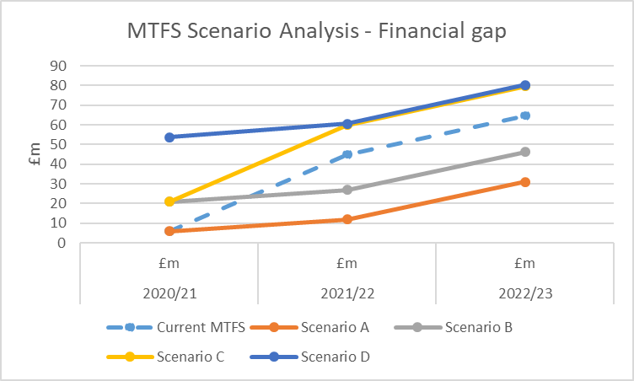

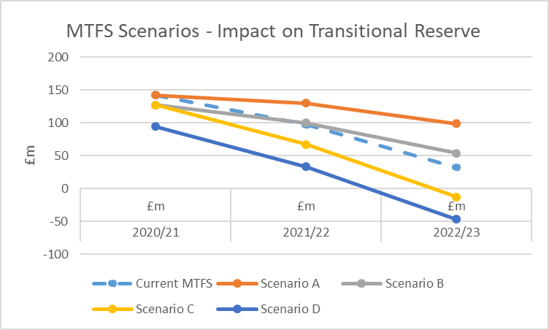

The scenarios presented clearly demonstrate the significant financial impact resulting from changes to the assumptions included within the MTFS. In all cases however, the council has sufficient reserves to support the gap through 2021/22 but only partway into 2022/23 for two of the scenarios. Scenario A represents a more positive position than assumed within the MTFS but a structural deficit would still remain and reinforces the importance of addressing the underlying cost drivers within the council to secure financial sustainability moving forward.

In addition, the MTFS contains assumptions across services for funding growth, demand, inflation and pay levels. The table below shows the impact of and increase or decrease of 1% over these key elements of the projected budget requirement.

 | Potential Full-Year Impact (£m)
Funding - Council Tax (1%) | +/- 5.123
Pay (1%) | +/- 3.500
Price Inflation (1%) | +/- 6.189
Demand (1%) | +/- 5.968

This stress testing gives confidence that the council can continue to live within its means for a number of years even in adverse circumstances. This does not however diminish or negate the need to make further savings but does demonstrate that the council continues to have sufficient resilience to deliver them in a measured and structured way.

